**DAILY ONLINE ACTIVITIES SUMMARY**

|  |  |  |  |  |  |  |  |  |
| --- | --- | --- | --- | --- | --- | --- | --- | --- |
| **Date:** | **21 JULY** | | | | | **Name:** | **Shanbhag Atish Manoj** | |
| **Sem & Sec** | **6th Sem ‘B’ Sec** | | | | | **USN:** | **4AL17CS085** | |
| **Online Test Summary** | | | | | | | | |
| **Subject** | | **Java Programming** | | | | | | |
| **Max. Marks** | | **--** | | **Score** | | |  | |
| **Certification Course Summary** | | | | | | | | |
| **Course** | **Bayesian Method For ML** | | | | | | | |
| **Certificate Provider** | | | **Coursera** | | **Duration** | | | **5 Weeks** |
| **Coding Challenges** | | | | | | | | |
| **Problem Statement:** | | | | | | | | |
| **Status:** | | | | | | | | |
| **Uploaded the report in GitHub** | | | | | **yes** | | | |
| **If yes Repository name** | | | | | <https://github.com/>atish-shanbhag/Updates | | | |
| **Uploaded the report in slack** | | | | | **yes** | | | |

**Java Programming**

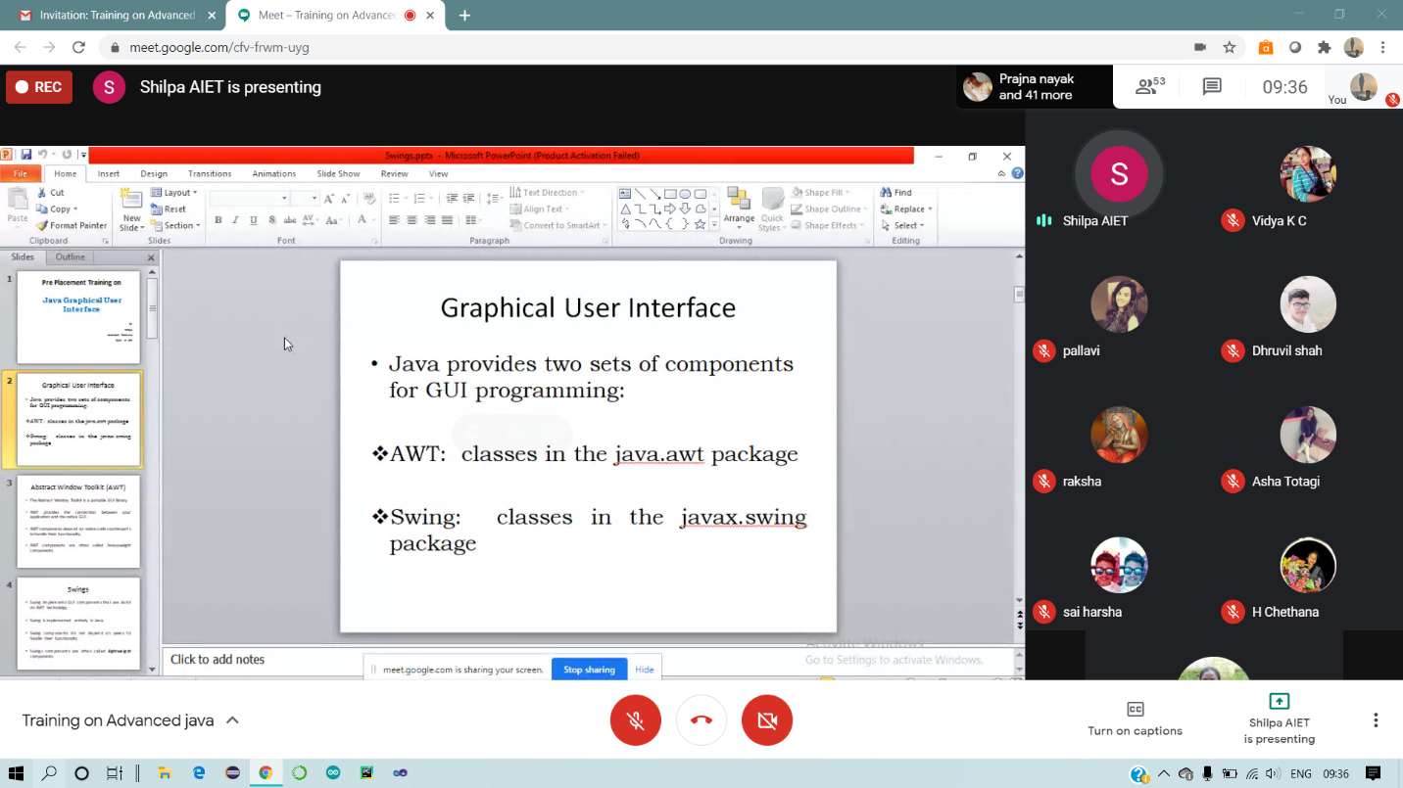

**Webinar**

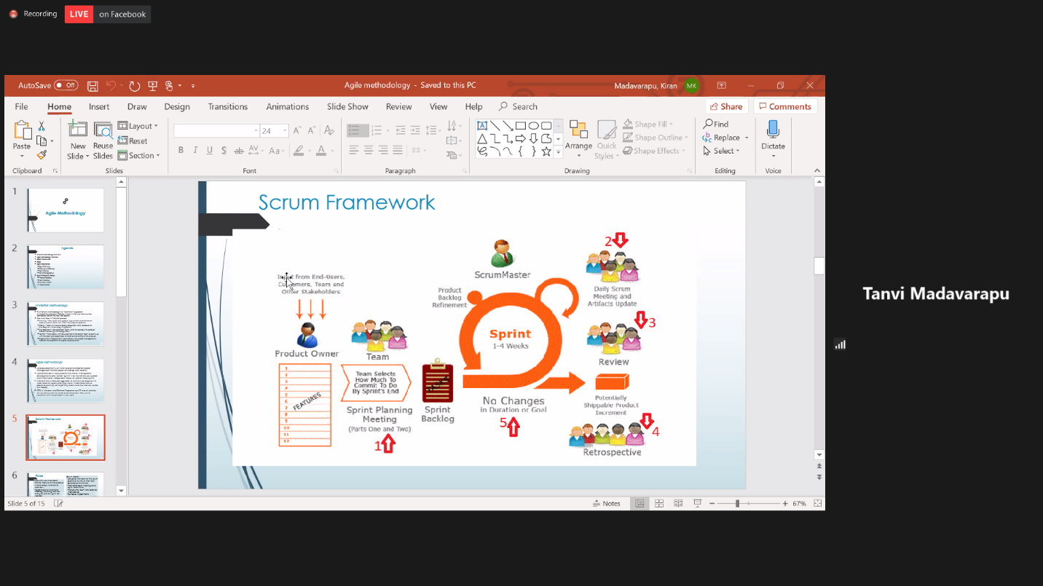

**Coursera:-Bayesian method for machine learning**

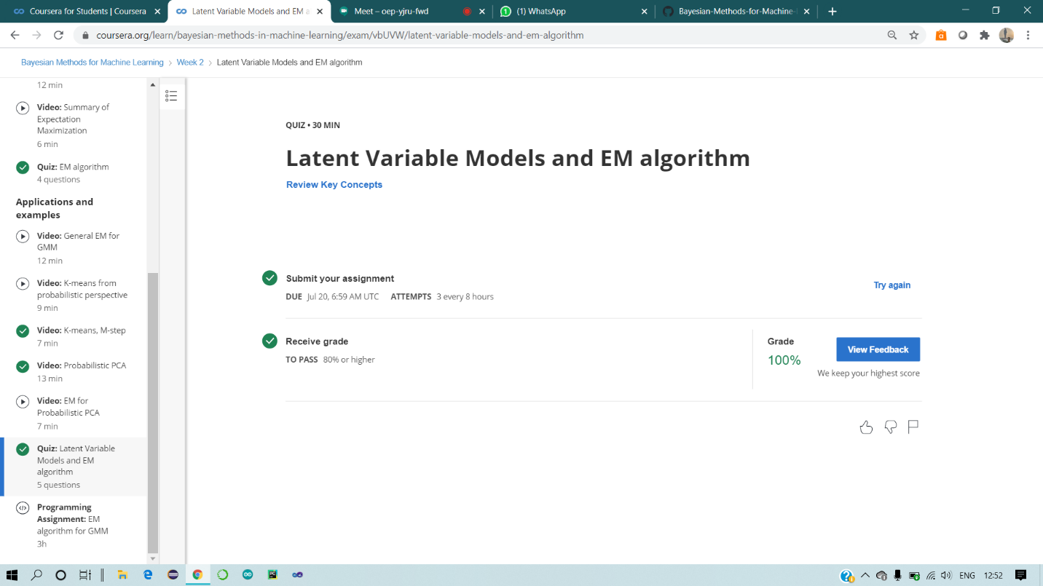

**1-For Report and daily coding challenges** 🡪

[**https://github.com/**](https://github.com/atish-shanbhag/Updates)**atish-shanbhag/Updates**